1. Export profile from old system and name ChibaSetUp

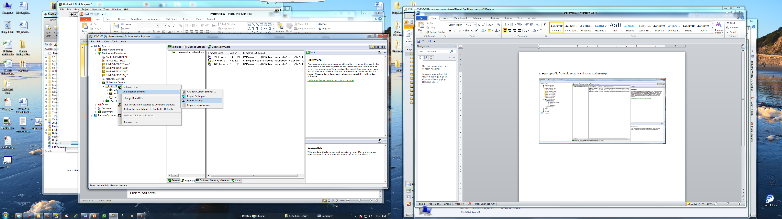

2. Import ChibaSetUp settings in new system

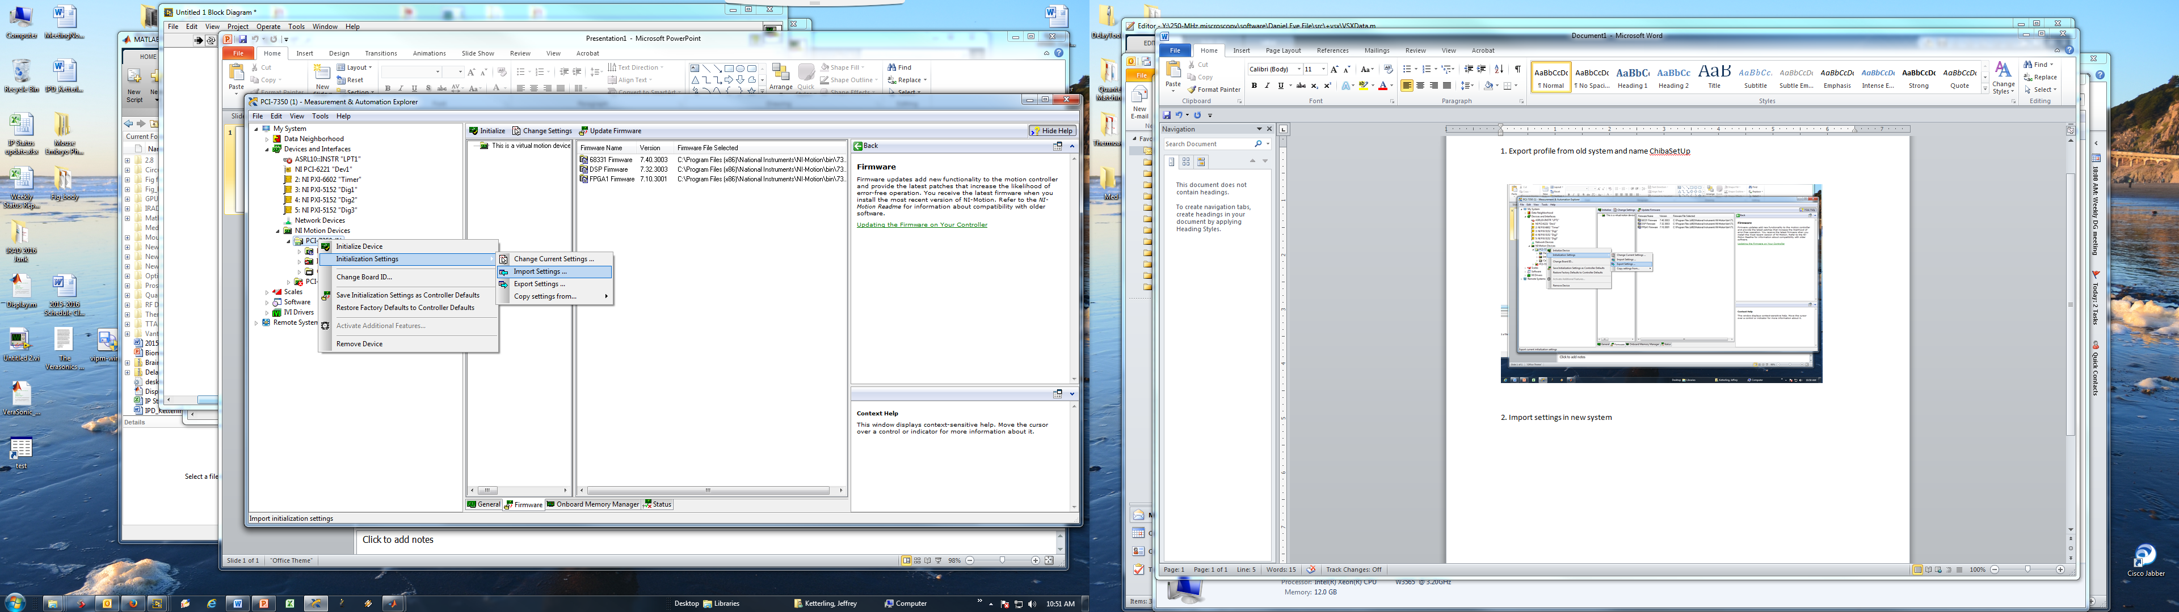

3. Create new profile called SMAC (This is the name that shows up instead of Default 7350 Settings) on the old system. Click and then rename My New Settings to SMAC.

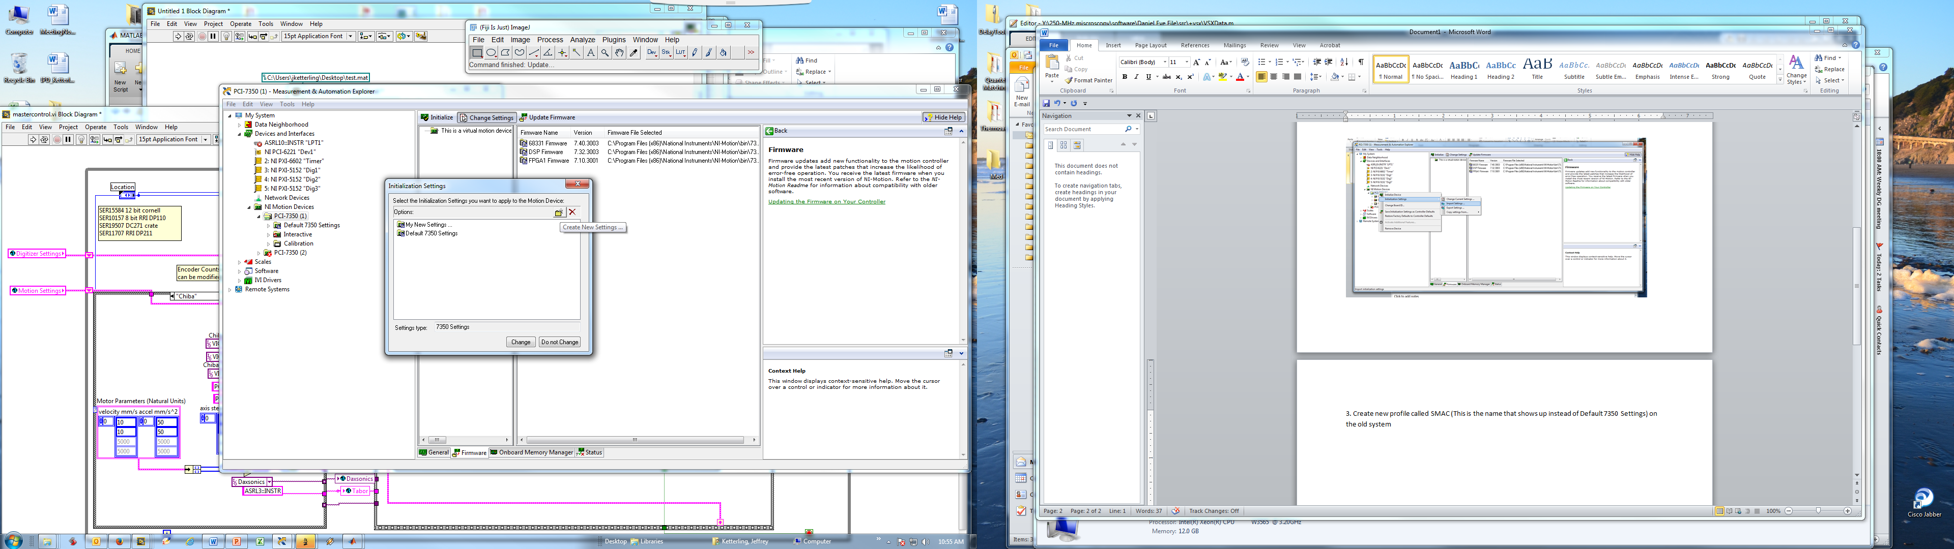

4. Now copy settings ChibaSetUp settings into SMAC profile.

